


AIOB SMS V-HUB Signaling Topology
- Message Routing (Signaling) and Billing recommendations as per GSMA SMS HUB Guidelines
- Network Design Considerations

Telcobright Telcobright (2022)- All Rights Reserved 1

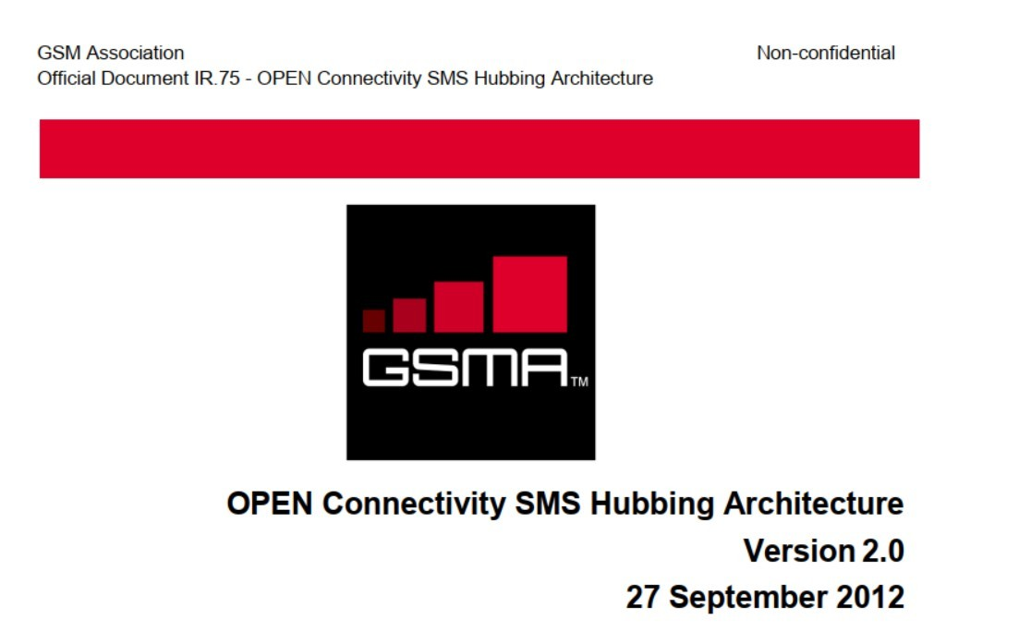
Important Recommendations from GSMA

Telcobright Telcobright (2022)- All Rights Reserved 2

SIGTRAN Protocol Stack for SMS Transit through SMS HUB

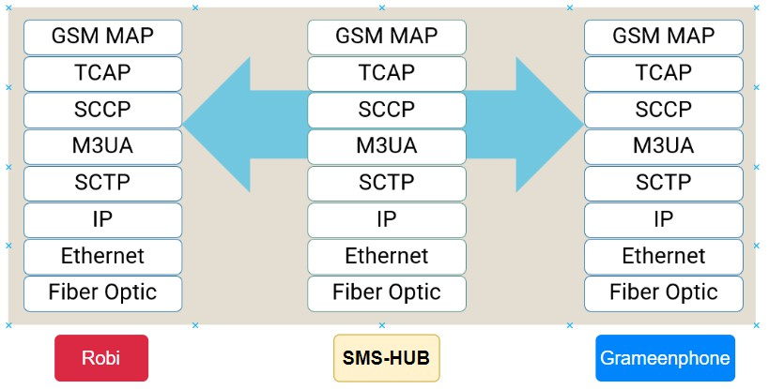

Telcobright Telcobright (2022)- All Rights Reserved 3

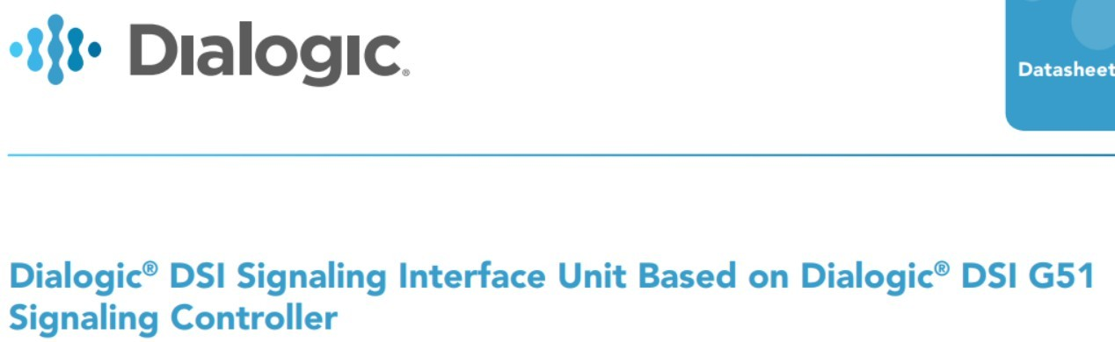

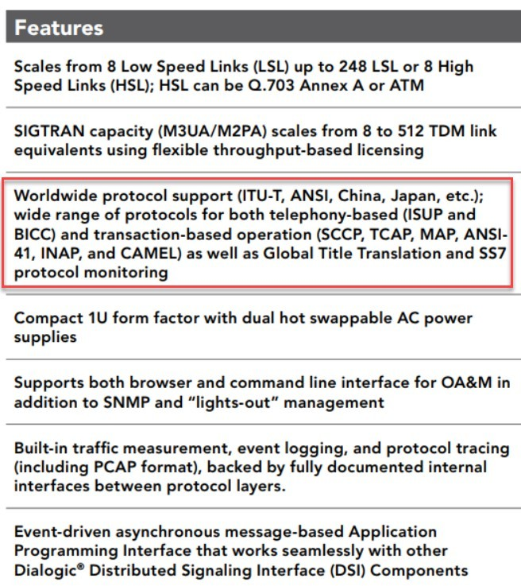
SMS HUB Equipment and Protocol Support

Telcobright Telcobright (2022)- All Rights Reserved 4

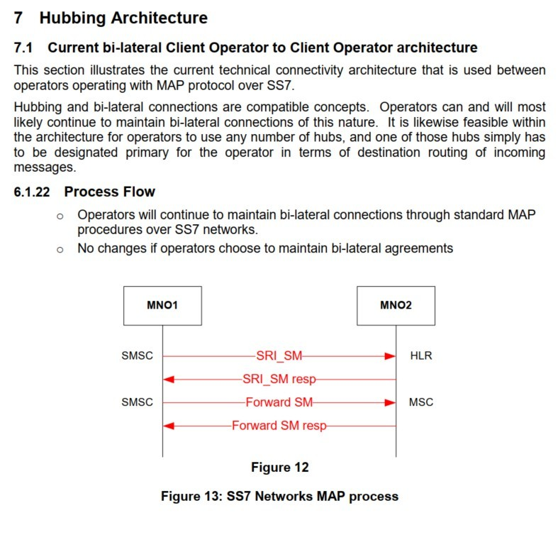
GSMA Process Flow for Signaling (Bilateral)

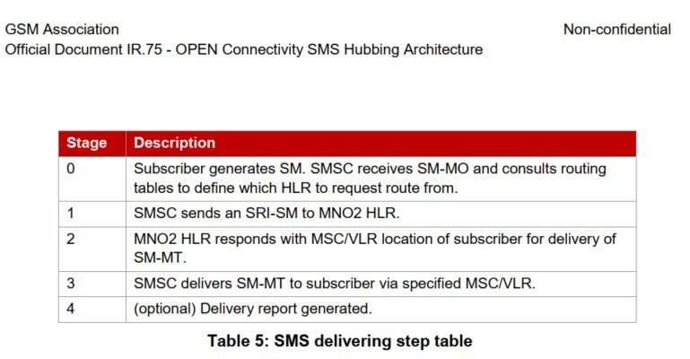

Telcobright Telcobright (2022)- All Rights Reserved 5

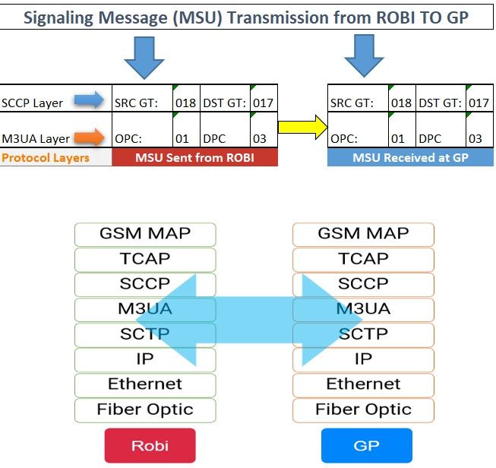
Example Message Routing (Bilateral)
- Robi wants to send MSU to GP GT=017
- Robi STP translates the GT to GP DPC=03
- MSU or signaling messages are passed directly from Robi OPC to GP DPC

Telcobright Telcobright (2022)- All Rights Reserved 6

GSMA Process Flow for Signaling through HUB
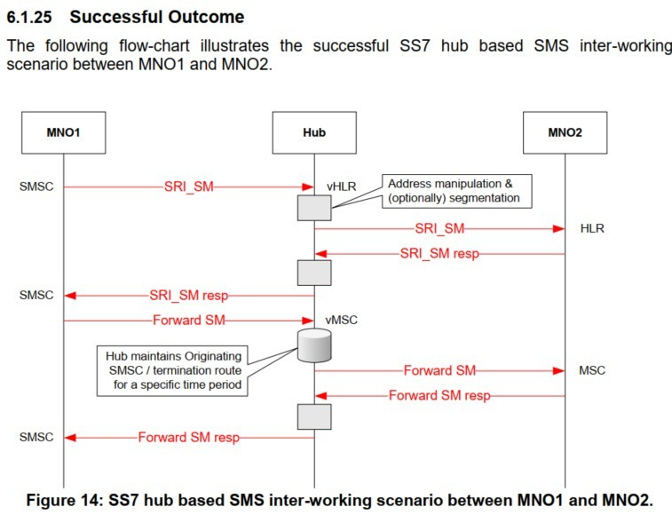

Telcobright Telcobright (2022)- All Rights Reserved 7

Example of Proposed Message Routing (Through SMS-HUB STP)
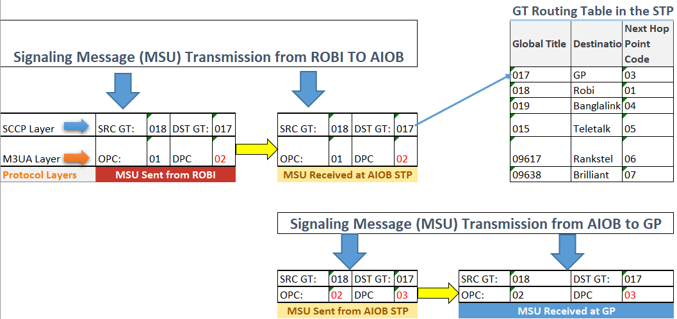
- Robi wants to send MSU to GP GT=017
- Robi STP translates the point code to AIOB STP DPC=02 and the packet reaches the STP
- AIOB STP looks up GT translation table and translates the GT 017 to next hop point code GP DPC 03 and forwards the MSU
Telcobright Telcobright (2022)- All Rights Reserved 8

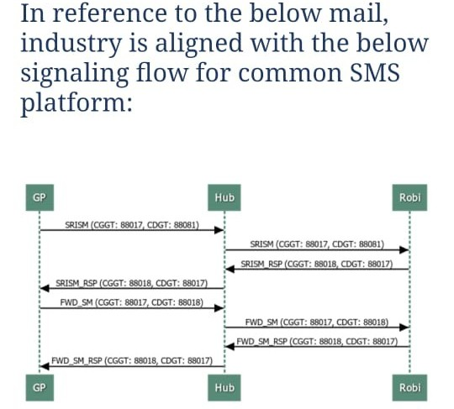
Acknowledgement from AMTOB on Signaling Process Flow

Telcobright 9
Telcobright (2022)- All Rights Reserved

GSMA Recommendations for Realization of Signaling

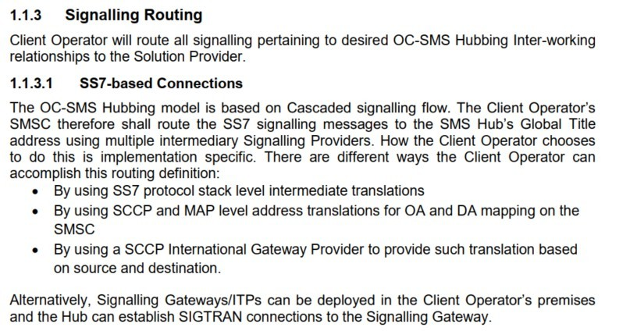

Telcobright Telcobright (2022)- All Rights Reserved 10

Recommendations on Preserving SCCP and MAP Addresses
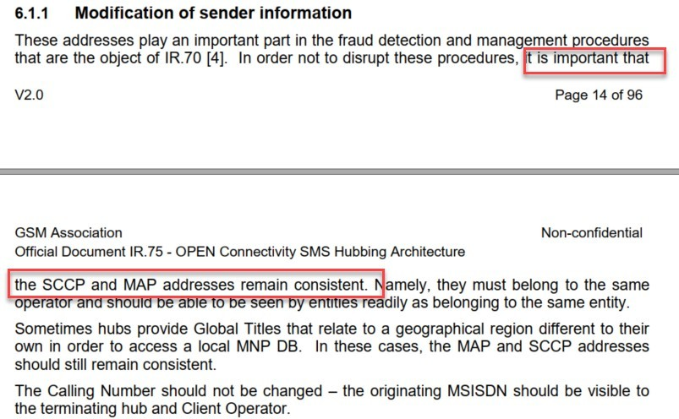

Telcobright Telcobright (2022)- All Rights Reserved 11

Recommendations on Billing
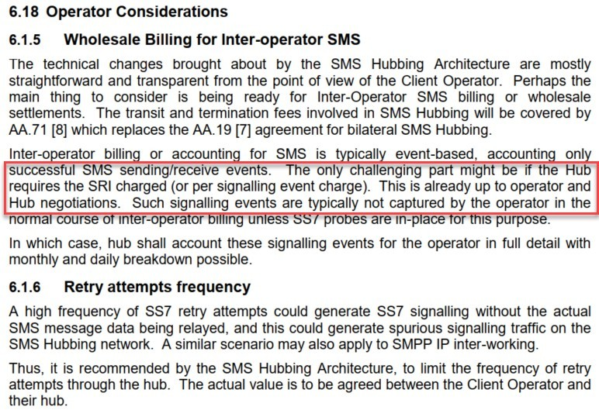
- General recommendation is to bill on successful SMS sending/receiving
- Optionally SRI can be charged, depends on HUB and operators negotiations
Telcobright Telcobright (2022)- All Rights Reserved 12

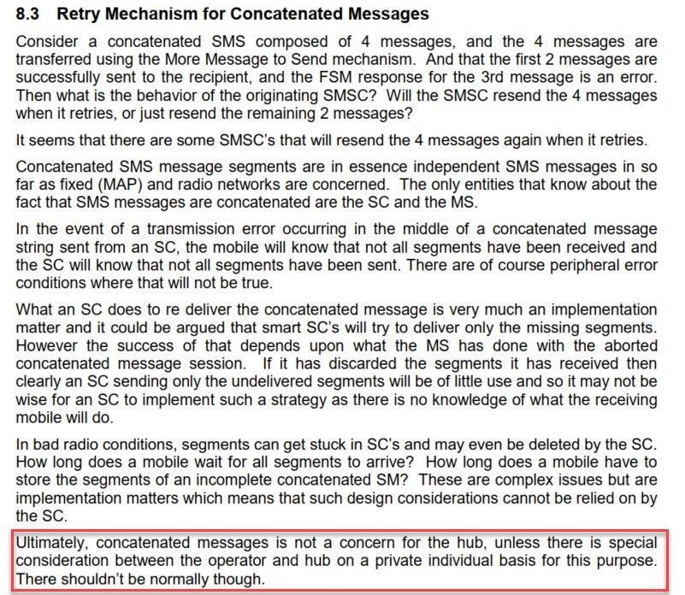
Recommendations on Concatenated Messages
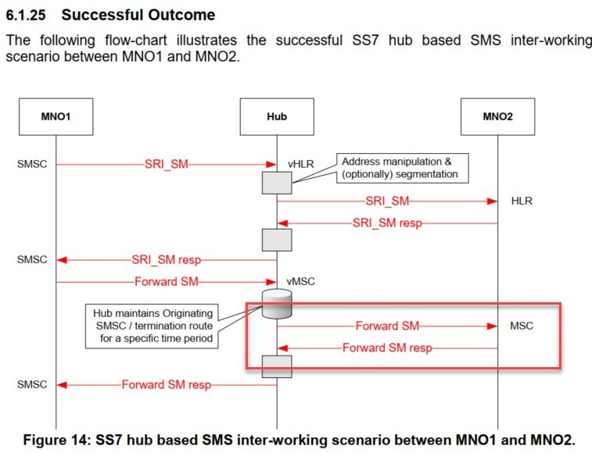

- MSG concatenation should not be a concern for Hub and hub will charge based on Forward SM Response for each Submission.

Telcobright Telcobright (2022)- All Rights Reserved 13

High Availability and Security at Various Protocol Layers
- Site Level HA or Redundancy
- Node Level HA
- Card Level HA through SCTP Multi-Homing
- IP backbone redundancy
  - Multiple physical links
  - BGP for dynamic and failover routing
- Security using IPSEC and GRE Tunnel (SS7 attack+ source spoofing)
- HA in IP Access Network
  - VRRP
  - Vlan Trunking
  - OSPF over GRE tunnel
Telcobright Telcobright (2022)- All Rights Reserved 14

Site Level STP HA or Redundancy for SIGTRAN OR SCTP

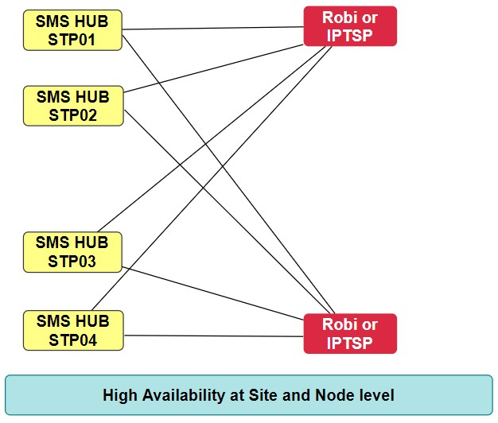
Link-1
Telcobright Telcobright (2022)- All Rights Reserved 15

Card Level HA through SCTP Multihoming

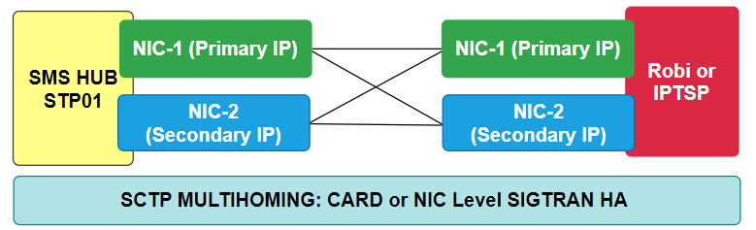

Telcobright Telcobright (2022)- All Rights Reserved 16

Use of BGP, IPSEC and OSPF

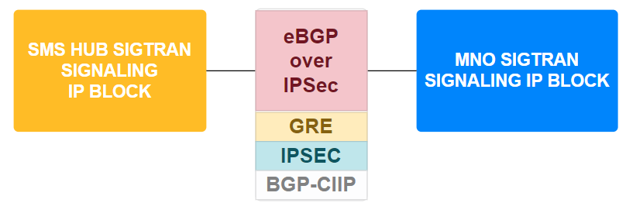
sigtran

Telcobright Telcobright (2022)- All Rights Reserved 17

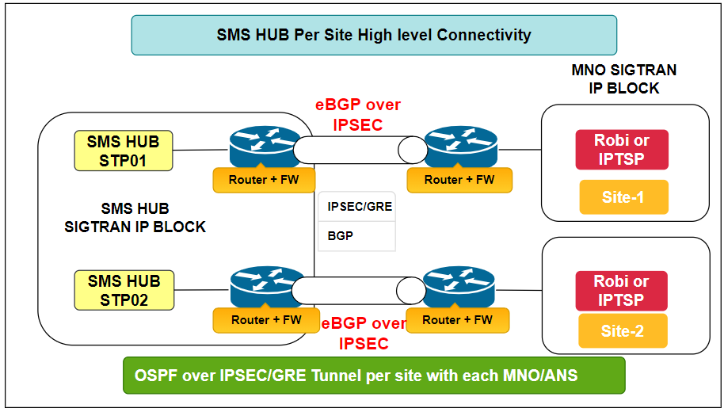
eBGP over IPSEC, One Session or Tunnel per Firewall Across Sites

Telcobright Telcobright (2022)- All Rights Reserved 18

Redundancy in IPSEC Path through BGP Backbone

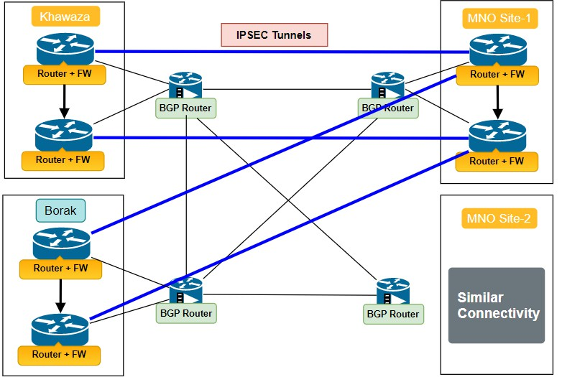
Telcobright 19
Telcobright (2022)- All Rights Reserved

Inter Site SMS Switching without Inter STP Link
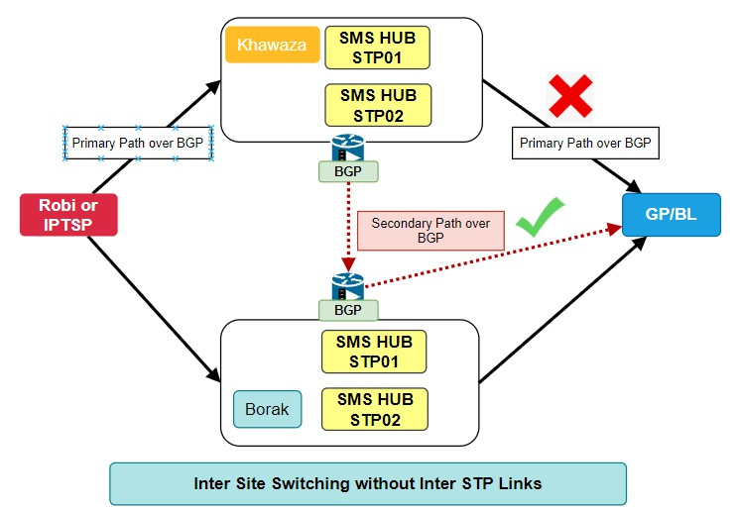
Telcobright Telcobright (2022)- All Rights Reserved 20

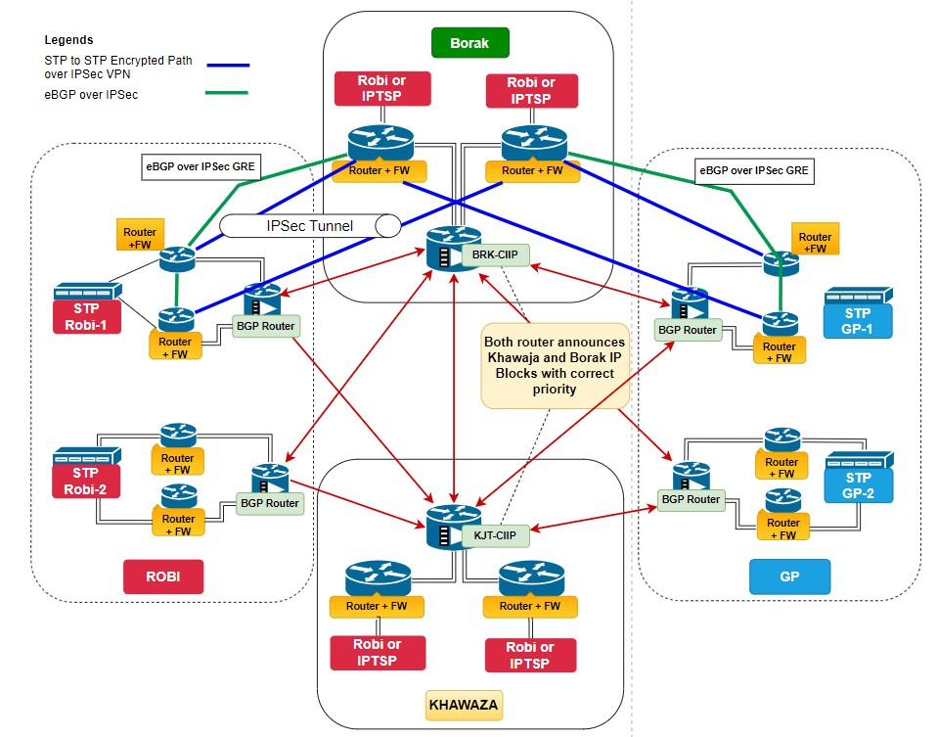
Overall Network Topology

Telcobright Telcobright (2022)- All Rights Reserved 21

